***As a Customer, I want to select menu items from a restaurant of my choice*.**

**Scenario 1: Customer selects one serving of each of the 3 menu items from the menu namely, green salad, fried chicken and chicken masala.**

**Scenario 2: Customer wants 6 servings of Fried Chicken. Restaurant Allows only 5 servings per customer.**

Acceptance criteria for scenario 1:

Given: Customer is on the menu page of the restaurant “Passage to India”. This restaurant has 4 menus, namely, 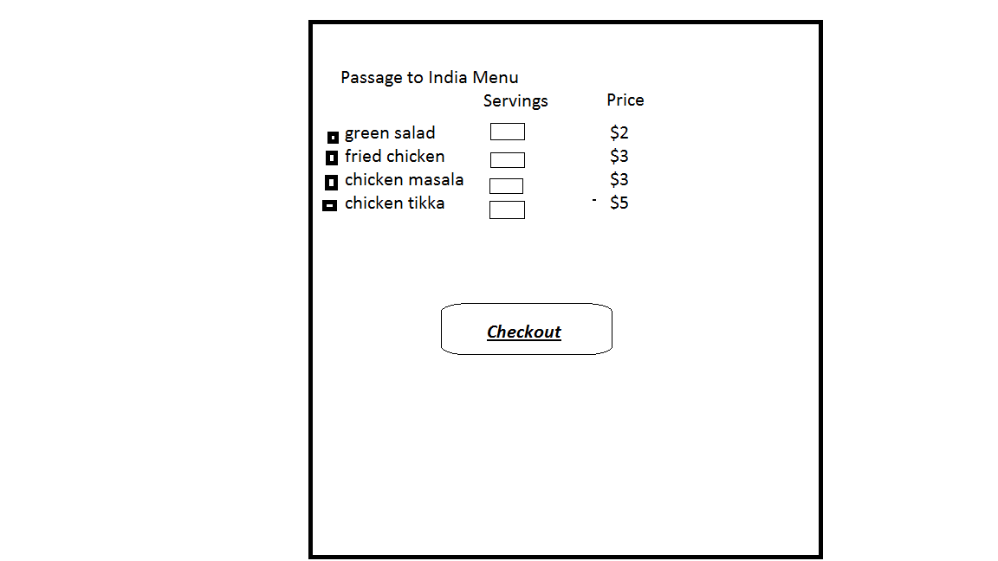 and chicken tikka.

When: Customer checks the check boxes for green salad, fried chicken, chicken masala and selects 1 serving of each of these 3 menus and clicks on Checkout button.

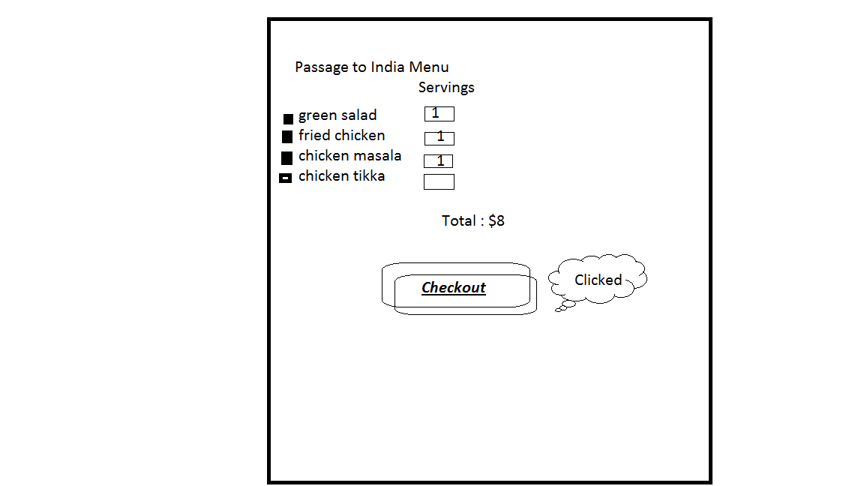

Then: Customer is taken to the Cart. Message is displayed: “Successfully added menu (green salad(1), fried chicken(1) and chicken masala(1) to the cart.” Cart shows the these three menus in the list.

